**A**

**Project Report**

**On**

**“Prift”**

**Prepared by:**

Ankit Shah(16it116)

Smit Sabhadiya(16it111)

**Under the supervision of**

Prof. Jalpesh vasa

A Report Submitted to

Charotar University of Science and Technology

for Partial Fulfillment of the Requirements for the

Degree of Bachelor of Technology

in Information Technology

IT345 Software Group Project-II (5th sem)

**Submitted at**



**DEPARTMENT OF INFORMATION TECHNOLOGY**

**Chandubhai S. Patel Institute of Technology**

**At: Changa, Dist: Anand – 388421**

**October 2018**



**CERTIFICATE**

This is to certify that the report entitled “Prift**"** is a bonafied work carried out by **Smit Sabhadiya(16IT111) and Ankit Shah(16it116)** under the guidance and supervision of **Prof. Jalpesh vasa** for the subject **Software Group Project-II (IT345)** of **5th**  Semester of Bachelor of Technology in **Information Technology** at Faculty of Technology & Engineering – CHARUSAT, Gujarat.

To the best of my knowledge and belief, this work embodies the work of candidate themselves, has duly been completed, and fulfills the requirement of the ordinance relating to the B.Tech. Degree of the University and is up to the standard in respect of content, presentation and language for being referred to the examiner.

|  |
| --- |
| Under supervision of,  Prof. Jalpesh vasa  Assistant Professor  Dept. of Information Technology  CSPIT, Changa, Gujarat. |
| Prof. Parth Shah  Head & Associate Professor  Department of Information Technology  CSPIT, Changa, Gujarat. |

**Chandubhai S Patel Institute of Technology**

At: Changa, Ta. Petlad, Dist. Anand, PIN: 388 421. Gujarat

TABLE OF CONTENTS

* Acknowledgement 5
* Abstract 6
* Chapter 1 Introduction 7

1.1 Project Summary 7

1.2 Scope 7

1.3 Objective 7

* Chapter 2 System Requirements Study 9

2.1 User Characteristics 9

2.2 Tools & Technology Used 9

* Chapter 3 System Design 10

3.1 Project Flow 10

* Chapter 4 Implementation Planning 11

4.1 Implementation Environment 11

4.2 Coding Standards 11

4.3 Snapshots of project 20

* Chapter 5 Limitations and Future Enhancement 22
* Chapter 6 Conclusion 23
* References 23

**LIST OF FIGURES**

|  |  |
| --- | --- |
| Fig. 4.3.1…………………………………….. | ………………………………………………...9 |
| Fig. 4.3.2…………………………………….. | ………………………………………………...10 |
| Fig. 4.3.3…………………………………….. | ………………………………………………...11 |
| Fig. 4.3.4…………………………………….. | ………………………………………………...11 |
| Fig. 4.3.5…………………………………….. | ………………………………………………...12 |
| Fig. 4.3.6…………………………………….. | ………………………………………………...12 |

**ACKNOWLEDGEMENT**

Working on this project “Prift” was a source of immense knowledge for us. We are really grateful to Dr. (Prof.) Parth Shah, HOD - Department of Information Technology, Dean - Faculty of Technology & Engineering for providing us with an opportunity to undertake this project in this university. We are highly thankful to Prof. Jalpesh Vasa for their active support, valuable time and advice during the study and in completing the assignment of preparing the said project within the time provided.

The successful completion of this project would not have been possible without the dedicated support from all our mentors and friends.

Smit Sabhadiya(16it111)

Ankit Shah(16it116)

**ABSTRACT**

This project “Prift” is developed to provides fast Online printing & Gifting for both home and businesses. It also provide High quality business cards, postcards, flyers, brochures, stationery and other online print products.It also provides the personalize gift store with 100+ products.The customer must have to register for the online printing and also to buy any type of cards,stationery and othe products.

**CHAPTER- 1: INTRODUCTION**

**1.1: Aim of the project**

The main aim to work on this project is to make the online printing facilities to the User,Also provide some High quality business cards, postcards, flyers, brochures, stationery and other online print products.It also provides the personalize gift store with 100+ products.

A prift is a project with help of you can avoid to go at the printing shop and standing for an hours in a queue. This project helps you to get online printing and shopping at home.this will make everyone one of us to make our things ours.

**1.2: Purpose:**

The main purpose of this project is to provide printing service and shopping services at home,it less time consuming than going to shop and print it.

**1.3: Scope:**

* The print shop owner will receive the total printing cost along with all documents to be printed.
* Connection with AWS(Amazon Web Services).
* Implementation in real time.
* Embedding with e-wallet.

**1.4: Objective:**

* Print–from-home.
* Shopping from home.
* Avoid standing in long queue.

.

**CHAPTER- 2: SYSTEM REQUIEMENTS**

**2.1: User characteristics:**

User must have their Email address and Password to log in and password for online printing and shopping.

**2.2: Tools and languages used (For development):**

**Tools:**

1. Mongodb
2. AWS
3. Sublime Editor

**Languages:**

1. Jquery
2. HTML-5
3. BOOT STRAP
4. Node js

**2.3: Assumptions and dependencies:**

We have assumed that user has the basic idea about the refer any website and have basic knowledge

About fill up the form and details online and using any e-commerce website.

**CHAPTER-3: SYSTEM DESIGN**

**3.1: Project Flow:**

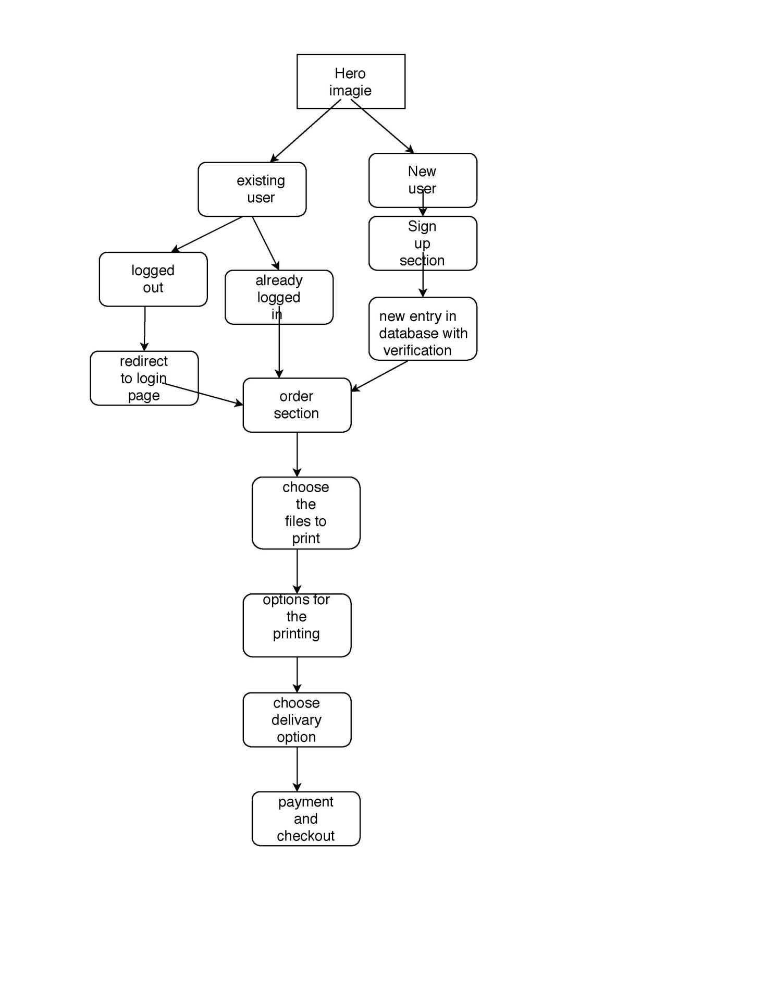

**CHAPTER- 4: IMPLEMENTATION PLANNING**

**4.1: Implementation environment:**

For multi user environment.

**4.2: Coding Standards**

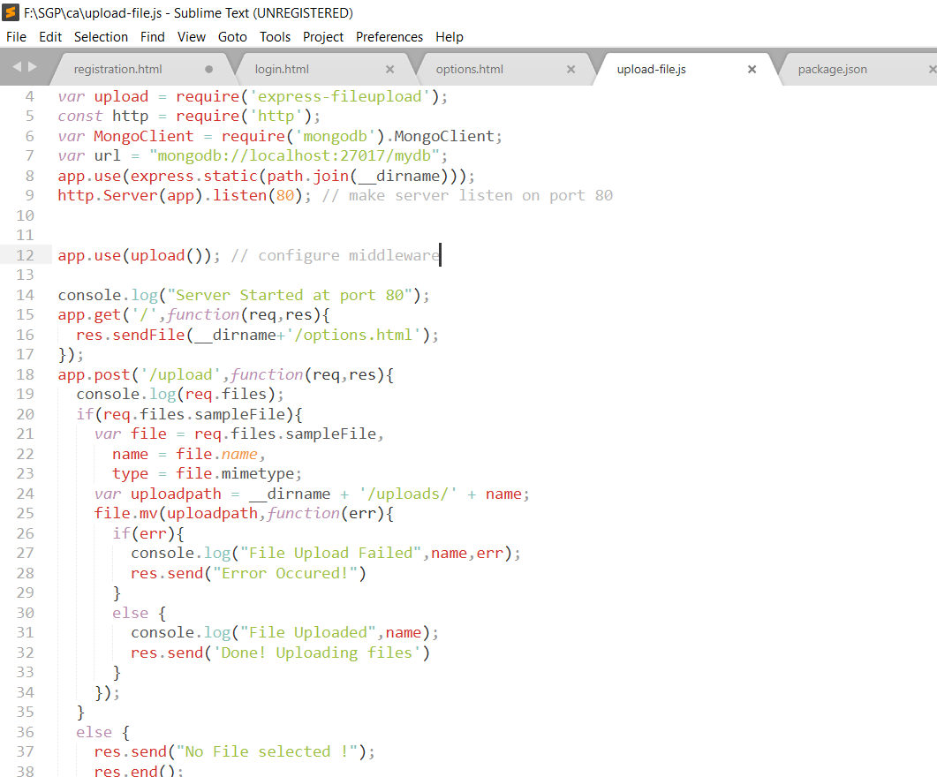

**4.3: Snapshots of project**

**Fig 4.3.1:Home Page**

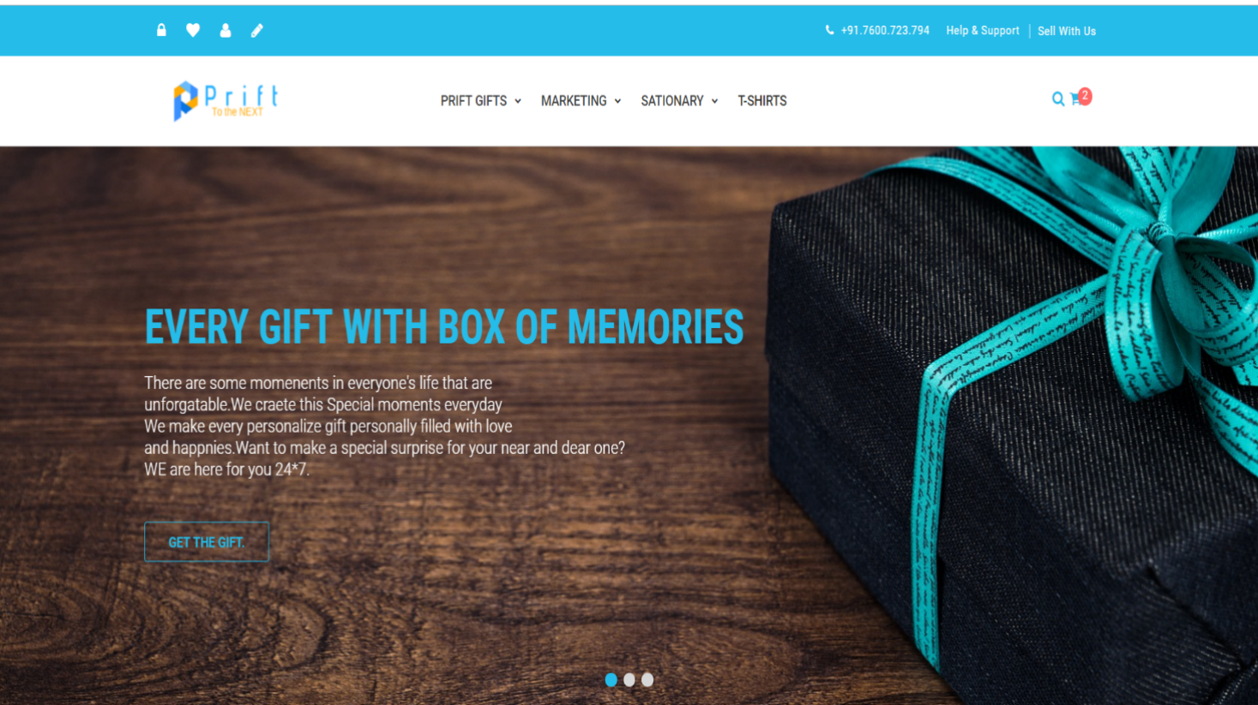

This is the homepage page of the website ,user can see the various product for sale.

**Fig 4.3.2: Regestration form**

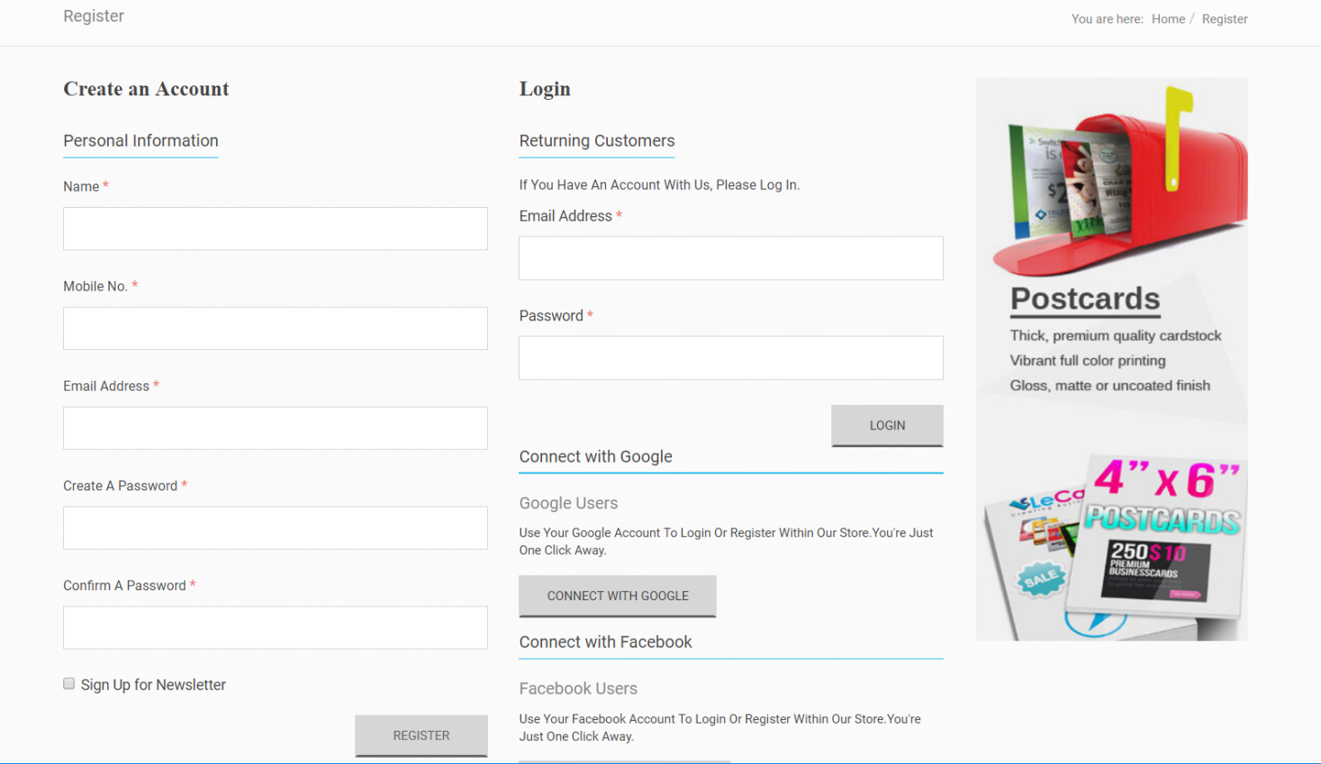

This is the registration and log in form of our website which through use can registration and log in for printing and shopping.

**Fig 4.3.3: User dashboard**

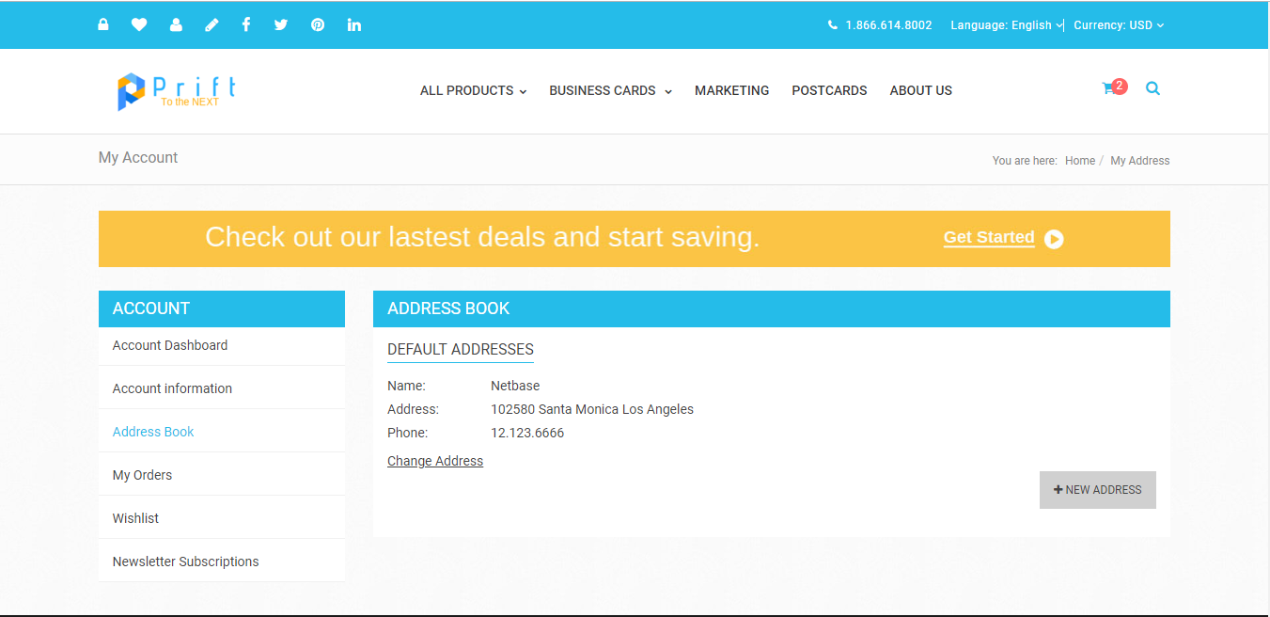

A beautiful clean and easy to use dashboard for each user come to our site.

**Fig 4.3.4:Contact Us**

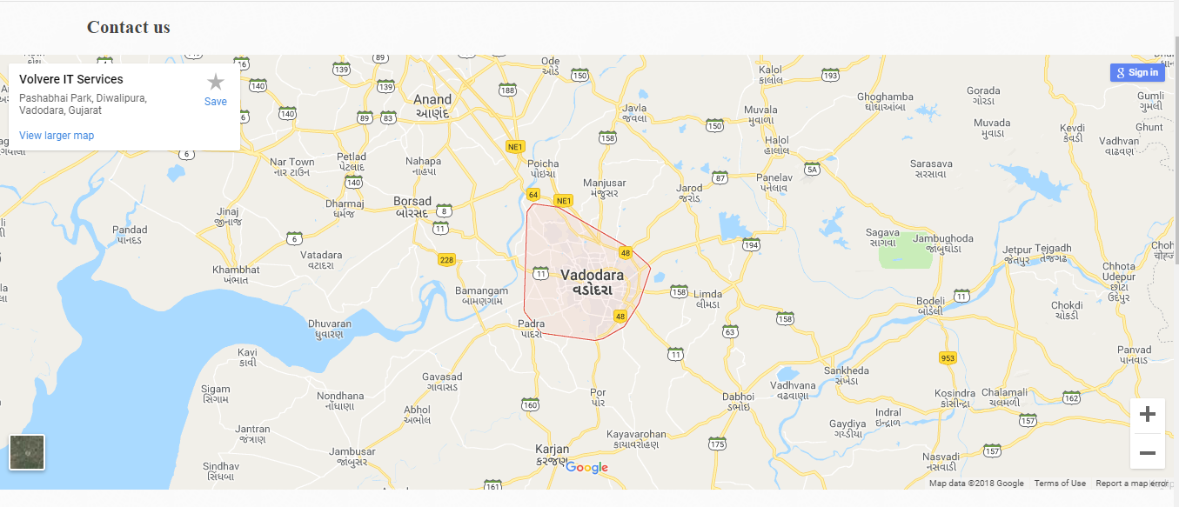

Here is the contact us page with the integration of Google maps api.

**CHAPTER-5: LIMITATIONS AND FUTURE ENHANCEMENT**

**5.1: Limitations**

* Only registered user can apply for online printing.
* It is operate only on local host this site is not online.
* It is not fully tested site so there may be issue related to data lick.

**5.2: Future Enhancements**

* **Security:**
* Make website more secure in terms of data security.
* **Reduce Time:**
* Reduce the site loading as number of user increase.
* **Payment:**
* Embedding with e-wallet.

**CHAPTER 6 : CONCLUSION**

**6.1: Conclusion**

Hence We conclude that our site is helpful for student and every person who love ,care any other person.We help every student to print their reports and presentation on the go and we deliver the product on time every time.We are also having 100+ great unique products that are going to make every user enable to gift something special for their special one.

**6.2: References**

1. [**https://nodejs.org**](https://nodejs.org)
2. [**https://www.w3schools.com/xml/ajax_intro.asp**](https://www.w3schools.com/xml/ajax_intro.asp)
3. [**https://www.mysql.com/**](https://www.mysql.com/)
4. [**https://aws.amazon.com/**](https://aws.amazon.com/)